SIMATS ENGINEERING (SAVEETHA SCHOOL OF ENGINEERING)
Department of Computer Science and Engineering
CO2 ASSESSMENT TOOL 1 – Scenario-Based Requirement Analysis

Course Code: | CSA10 / CSA1063 | Course Title: | Software Engineering
CO Assessed: | CO2 | Assessment: | Assessment Tool 2 – Scenario-Based Requirement Analysis
Weightage: | 20% | Total Marks: | 25
CO2 Statement: | Perform detailed requirements analysis, design scalable architectures, and prioritize features with a focus on cross-disciplinary skills
Student Name: |  | Reg. No.:
Date: |  | Duration: | 60 minutes

Code of Conduct
I _________________RAKCHA A(192311421)_________ (Name / Reg No) certify that this submission is my original work and that I have adhered to the guidelines specified for this assessment. I understand that any violation of academic integrity rules will result in disciplinary action.
Signature of the Student: ____________RAKCHA_____________
Annexure A – Scenario-Based Requirement Analysis
Instructions to Students:
Each student will be assigned an individual software project problem statement. Analyze the given scenario and prepare a complete Software Requirement Analysis document by following the steps below.

Question
Based on the assigned problem statement, perform a Scenario-Based Requirement Analysis and prepare a Software Requirement Specification (SRS) document. Your analysis should include the following:
- Study and Analyze the Scenario
Business Domain
The system belongs to the warehouse and inventory management domain. It helps organizations manage products, stock, warehouse locations, orders, and product movement.
Stakeholders
- Warehouse Manager
- Inventory Manager
- Warehouse Staff
- Admin
- Suppliers
- Customers/Order Management Team
Existing Challenges
- Manual inventory records may contain errors.
- Difficulty in locating products.
- Stock shortages and overstocking.
- Slow order processing.
- Lack of real-time stock information.
- Difficulty in generating reports.
System Objectives
- Maintain accurate inventory information.
- Track product locations.
- Automate stock updates.
- Provide low-stock alerts.
- Improve order processing.
- Generate inventory reports.
- Reduce manual errors.
- Identify Functional and Non-Functional Requirements
Functional Requirements
- User Login: Users can securely log in based on their roles.
- User Management: Admin can add, update, and remove users.
- Product Management: Users can add, update, delete, and search products.
- Inventory Management: System maintains current stock quantities.
- Location Tracking: System records the warehouse location of each product.
- Receiving: Staff can record newly received products.
- Stock Transfer: Staff can transfer products between locations.
- Order Management: System manages customer orders.
- Picking and Packing: Staff can pick and pack products for orders.
- Dispatch: System records dispatched products and updates stock.
- Low Stock Alert: System alerts users when stock reaches the minimum level.
- Reports: System generates inventory, order, and stock movement reports.
Non-Functional Requirements
- Performance: The system should respond quickly to user requests.
- Security: Only authorized users can access system functions.
- Reliability: Inventory data should remain accurate and consistent.
- Usability: The interface should be simple and easy to use.
- Scalability: The system should support more products and users in the future.
- Maintainability: The system should be easy to update and maintain.
- Availability: The system should be available during warehouse working hours.

- Identify Actors and Use Cases
Actors
Admin
- Login
- Manage users
- Manage products
- View reports
Warehouse Manager
- Monitor inventory
- Manage orders
- View reports
Warehouse Staff
- Receive products
- Store products
- Transfer stock
- Pick and pack
- Dispatch orders
Inventory Manager
- Monitor stock
- View low-stock alerts
- Manage reorders
Supplier
- Supply products
- Provide delivery information
Main Use Cases
Actor | Use Cases
Admin | User management, Product management, Reports
Warehouse Manager | Inventory monitoring, Order management, Reports
Warehouse Staff | Receive, Store, Transfer, Pick, Pack, Dispatch
Inventory Manager | Stock monitoring, Alerts, Reorder
Supplier | Supply products, Delivery updates
Use Case Diagram
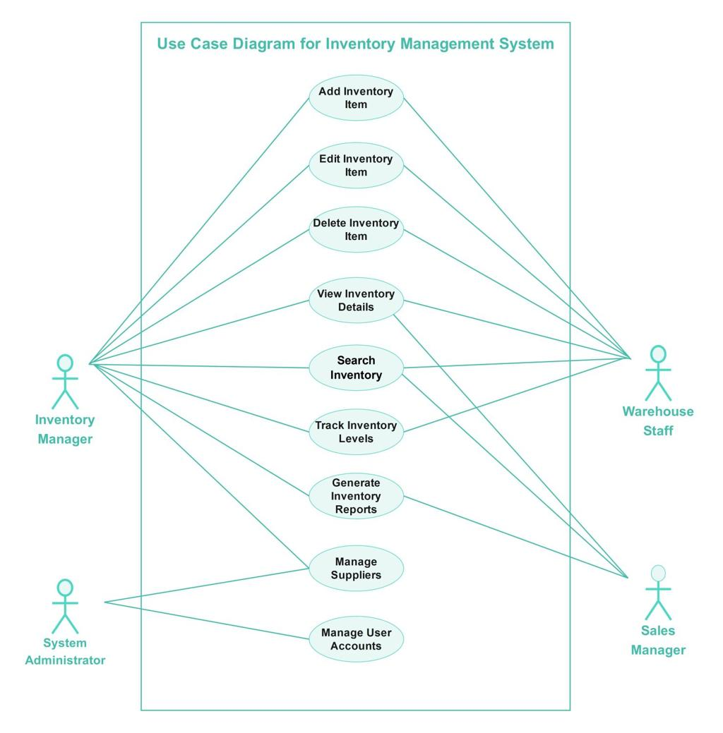
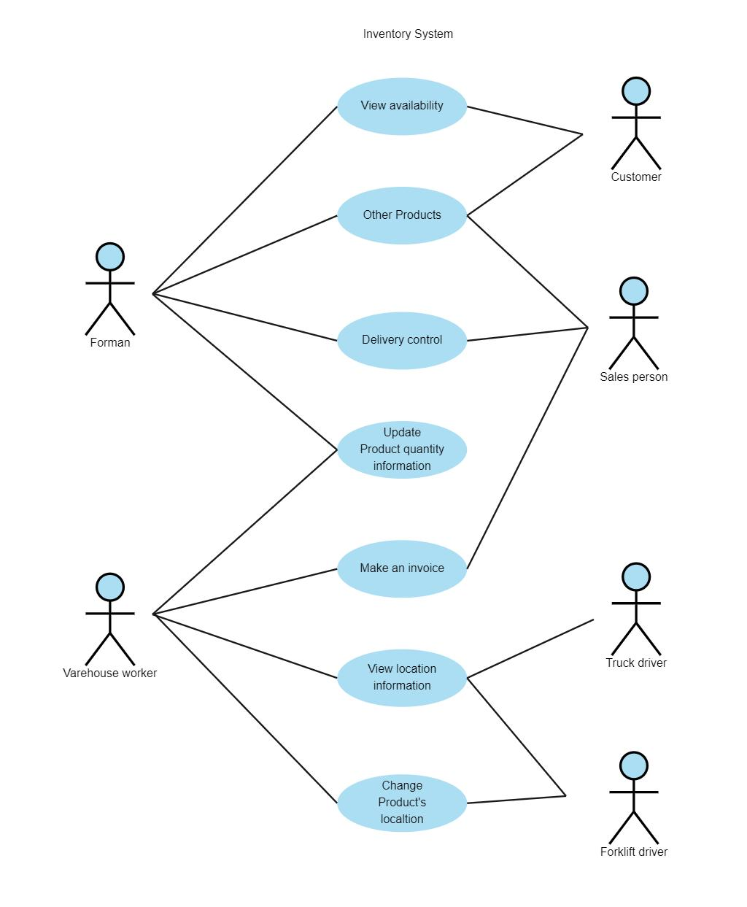
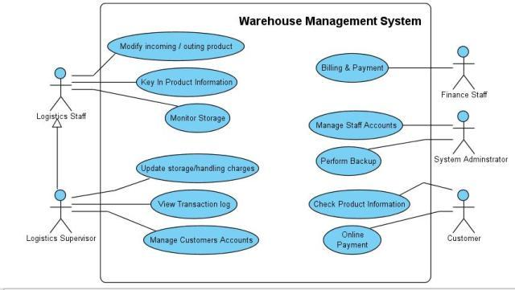
- Prepare the Software Requirement Specification (SRS)
Develop an SRS document containing:
  - Introduction
  - Problem Description
  - Scope of the System
  - Functional Requirements
  - Non-Functional Requirements
  - Use Case Descriptions
  - Data Requirements
  - External Interface Requirements
  - System Features
- Identify Assumptions and Constraints
Introduction
The Smart Warehouse Inventory Management Platform is designed to automate warehouse operations and manage inventory efficiently.
Problem Description
Manual warehouse management can cause incorrect stock information, misplaced products, delayed orders, and difficulty in tracking inventory.
Scope
The system covers:
- User management
- Product management
- Inventory tracking
- Warehouse location tracking
- Receiving and transfer
- Order processing
- Picking and packing
- Dispatch
- Alerts
- Reports
Use Case Description – Receive Product
Actor: Warehouse Staff
Steps:
- Staff selects the receiving option.
- Enters product and quantity details.
- Enters supplier information.
- System validates the details.
- System updates inventory.
- System records the transaction.
Data Requirements
The system stores:
- User details
- Product details
- Stock quantity
- Warehouse locations
- Supplier details
- Customer orders
- Inventory transactions
External Interface Requirements
The system may support:
- Web interface
- Barcode/QR scanner
- Database
- Notification service
- Order management system
System Features
- Real-time inventory tracking
- Product location tracking
- Low-stock alerts
- Order management
- Dashboard
- Reports
- Secure login

5. Assumptions and Constraints
Assumptions
- Users have valid login credentials.
- Product information is entered correctly.
- Warehouse has internet/network connectivity.
- Employees are trained to use the system.
- Each product has a unique ID.
Constraints
Technical
Requires suitable hardware, database, and network.
Operational
Staff must follow proper warehouse procedures.
Economic
Development, hosting, and hardware costs must be within budget.
Legal
User and customer information must be protected.
Time
Development, testing, and deployment must be completed within the project schedule.

- Validate Requirement Completeness and Consistency
- All major stakeholder requirements are included.
- Functional and non-functional requirements are clearly defined.
- Requirements should not contradict each other.
- Duplicate requirements should be removed.
- Ambiguous terms such as "very fast" should be replaced with measurable requirements.
- Missing features such as backup, audit logs, barcode scanning, and data recovery can be added.
Conclusion
The Smart Warehouse Inventory Management Platform provides an efficient and automated way to manage warehouse inventory. It improves stock accuracy, product tracking, order processing, and reporting while reducing manual work and errors.

Rubrics for Calculation
Criteria | Excellent (4 Marks) | Good (3 Marks) | Satisfactory (2 Marks) | Needs Improvement (1 Mark)
Scenario Understanding and Problem Analysis (30%) | Demonstrates thorough understanding of the scenario, stakeholders, objectives, and business context with clear analysis. | Demonstrates good understanding with minor omissions. | Basic understanding with limited analysis. | Poor understanding; major aspects missing or incorrect.
Functional and Non-Functional Requirement Identification (25%) | Clearly identifies comprehensive, accurate, and well-classified functional and non-functional requirements. | Identifies most requirements with minor classification errors. | Identifies only basic requirements; several omissions. | Requirements are incomplete, inaccurate, or poorly classified.
Actor Identification and Use Case Modelling (20%) | Correctly identifies all relevant actors and use cases; use case diagram is complete, accurate, and follows UML standards. | Most actors and use cases identified; diagram has minor errors. | Limited actors/use cases identified; diagram partially correct. | Actors/use cases missing or incorrect; diagram absent or inaccurate.
Software Requirement Specification (SRS) Documentation (15%) | SRS is well-structured, complete, professionally organized, and includes all required sections. | SRS is organized with minor missing sections or formatting issues. | SRS includes only essential sections with limited detail. | SRS is incomplete, poorly organized, or lacks essential components.
Assumptions, Constraints, and Requirement Validation (10%) | Clearly identifies realistic assumptions and constraints; validates requirements for completeness, consistency, and ambiguity with appropriate justification. | Identifies most assumptions and constraints; validation is adequate. | Limited assumptions/constraints; validation is superficial. | Assumptions, constraints, and validation are missing or incorrect.

Criteria | Mark
Scenario Understanding and Problem Analysis (30%) | /5
Functional and Non-Functional Requirement Identification (25%) | /5
Actor Identification and Use Case Modelling (20%) | /5
Software Requirement Specification (SRS) Documentation (15%) | /5
Assumptions, Constraints, and Requirement Validation (10%) | /5
TOTAL | /25

